Building Diamond and Graphite

You can use a molecular modelling kit to make the structures of diamond, graphite and other carbon allotropes. You should be able to recognise these structures by their shape and number of bonds.

Diamond
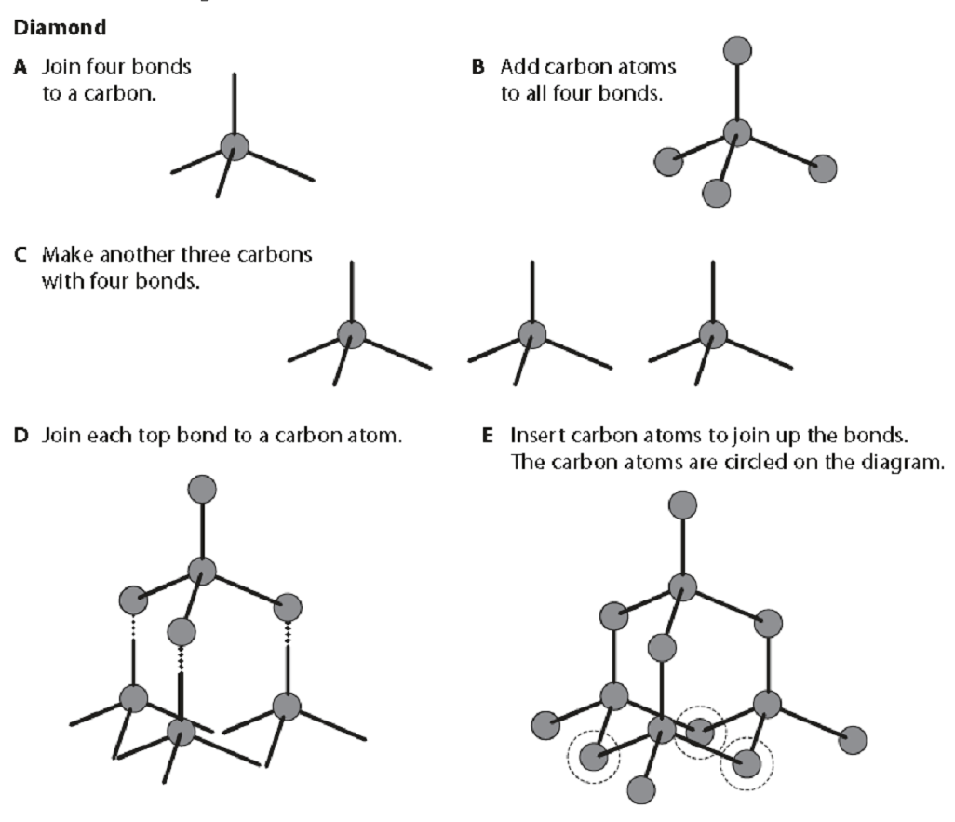

Graphite
